**After-school assignment of Chapters 10 and 11 (100’)**

**Q1: What are physical adsorption and chemistry? What's the difference? (30’)**

* Physical adsorption is exothermic, giving up an amount of heat similar to the heat of condensation. **(6’)**
* Chemisorption involves the breaking and re-forming of bonds, and is much more energetic than physical adsorption. **(6’)**
* The state of matter of the vapor molecules on the surface can be somewhere between liquid and vapor, and there can be either several layers or a single layer of molecules on the surface. **(10’)**
* Physical adsorption is reversible, and this characteristic is used as a means of separating VOCs from air. **(8’)**

**Q2: What is the reaction rate constant? What formula can be used to calculate the reaction rate constant? What do the parameters in the formula represent? (30’)**

* Reaction rate constant (k) is a quantitative expression of chemical reaction rate ‌. Its physical significance is that the value is equivalent to the reaction rate when the substances participating in the reaction are at the unit concentration (1 mol·L⁻¹), so it is also called the specific rate of reaction. ‌**(15’)**
* The rate constant k is usually represented by an Arrhenius equation such as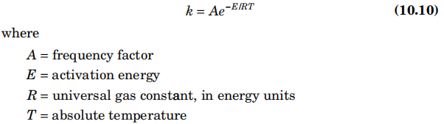**(30’)**

**Q3: Solve Problems 11.4 and 11.5 on page 379. (40’)**

* Problem 11.4 **(15’)**

T99=577-10.0(8)+110.2(1)+0+0+0.586(924)-0-0+85.2(1.25)-0+0-76.1(ln0.7)=1282℉

* Problem 11.5 **(25’)**

(c) Method of Cooper et al.

* First, we rearrange Eq. (11.19) and calculate the required value of k.k==6.58 s-1 **(4’)**
* From Eq. (11.18), we calculate E asE = – 0.00966(106) + 46.1 = 45.1 kcal/mol **(4’)**
* We calculate S from Eq. (11.17), and estimate Z‘ from Figure 11.5.Thus, S=16/106=0.151, **Z‘ =3.36×1011****(4’)**
* For an assumed oxygen mole fraction of 0.15 and a pressure of 1atm, we calculate A from Eq. (11.16) asA=3.36(10)^11(0.151)(0.15)(1)/0.08205=9.28(10)10 S-1 **(4’)**
* Finally, we rearrange Eq. (11.15) to solve for T, knowing k, A, and E.Thus,T=−E/(R×ln(k/A))= −45100/(1.9871×ln(6.58/9.28(10)10))=971 K **(7’)**
* ℉=32+1.8×(k-273.15)=1288 °F **(2’)**